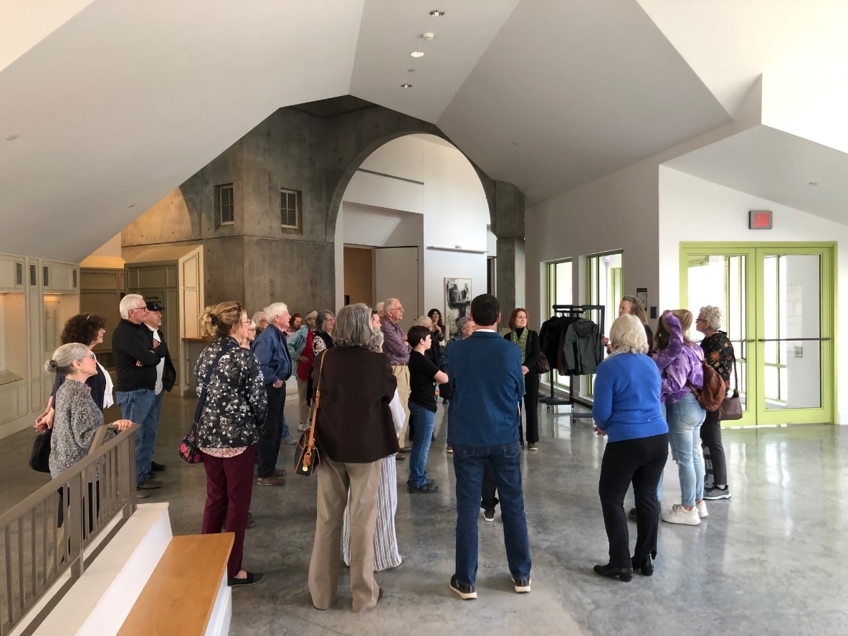
A group of thirty Winfield and Arkansas City art enthusiasts toured “To the Stars Through Art: A History of Art Collecting in Kansas Public Schools: 1900-1950” exhibition at the Miriam F. Beach Museum in Manhattan on Saturday, March 23.

Madeline Norland, chair of the USD 465 Art Collection advisory committee, noted that Elizabeth Seaton, museum curator, conducted extensive research across Kansas for seven years before launching the exhibition at the Kansas State University site. Seaton, a graduate of Winfield High School, discovered that more than ninety schools had acquired important works of art during those five decades, but few more than a dozen have retained them. Ten pieces from the USD 465 Art Collection of more than 150 items are a part of the exhibition.

Norland, who organized the trip, said those participating in the “day of learning,” observed how physical objects of art can be learning tools in the classroom. “The use of art in cross-curricular teaching has been proven to aid as a part of the conversation with students for higher academic scores and higher retention of students through high school.”

The USD 465 collection is in the process of being preserved, adequately stored and placed in schools and public spaces for the enjoyment and education of all ages, Norland stated.

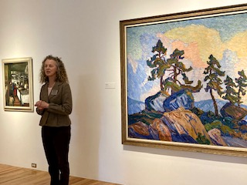

Liz Seaton, Curator of the Miriam F. Beach Museum giving a tour for Winfield & Arkansas City art enthusiasts 3.23.24.

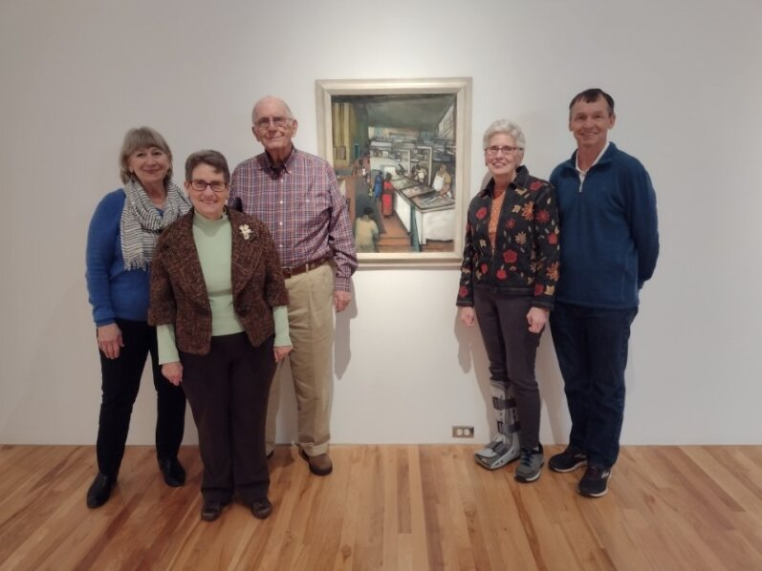
Members of the Art Advisory Committee present at the tour of Art in Kansas Public Schools with one example of the USD 465 Foundation Art Collection included in the show.

